INTERACTION AND HEALTH

1. INTRODUCTION

Like all living things, human beings have three life processes: nutrition, interaction and reproduction. We use different body systems for each of these processes. In this unit you will learn about how body systems work with interaction.

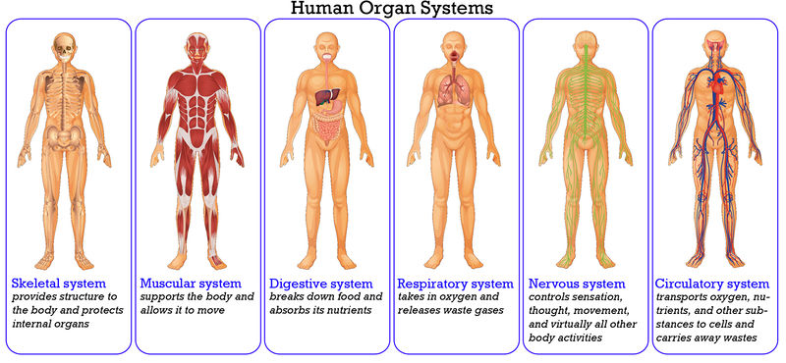

2. INTERACTION

Interaction is a vital function of living things. Like all living things, we interact with our environment. Living things react to their environment to survive. For example, the roots of a plant move towards water, seals stand close together to keep warm or we stop crossing a street if a car is coming. The five senses, the nervous system and the locomotor system all work together to make sure we do this.

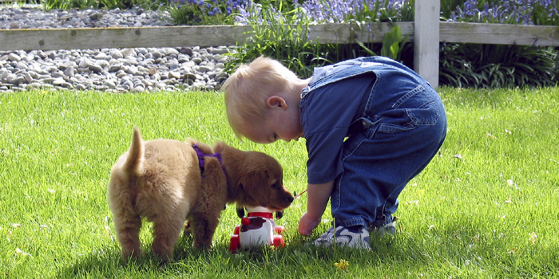

2.1. THE NERVOUS SYSTEM

One or more of our senses send a message to the brain (like a computer) along the nerves.The brain then sends instructions along the nerves to the locomotor system.

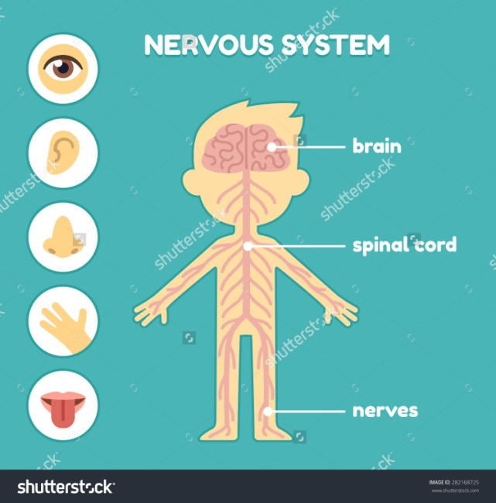

The *main parts* of the nervous system are:

a) **The brain**, inside the skull, receives information and give orders to the body to respond.

b) **Nerves**, tiny tubes in the body, carry information from the sense organs to the brain and from the brain to the organs.

There are *two types of movements* in our body:

a) **Involuntary** movement: we do not think about it, like breathing, the beating of the heart or digesting a banana.

b) **Voluntary** movement: other times it is voluntary; when you turn the pages of a comic, you move your fingers and hands. When you read, your eyes are moving. These movements are happening because you are making them happen.

2.2. THE LOCOMOTOR SYSTEM

The locomotor system allows us to move. When the locomotor system receives an instruction from the brain it goes into action.

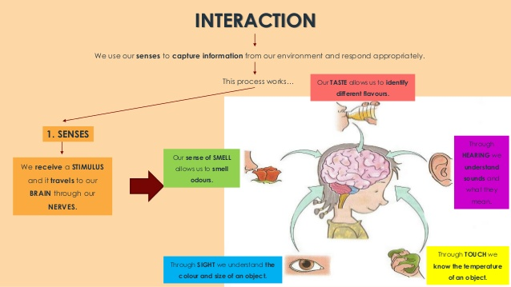

3. HEALTH

The secret to a healthy lifestyle is to have **healthy habits**. WE ARE WHAT WE EAT. When we usually eat things that are good for us, we feel better because our body gets stronger. So we have to look after our body.

